Software Environment

Java Technology

Java technology is both a programming language and a platform.

The Java Programming Language

The Java programming language is a high-level language that can be characterized by all of the following buzzwords:

    - Simple
    - Architecture neutral
    - Object oriented
    - Portable
    - Distributed
    - High performance
    - Interpreted
    - Multithreaded
    - Robust
    - Dynamic
    - Secure

With most programming languages, you either compile or interpret a program so that you can run it on your computer. The Java programming language is unusual in that a program is both compiled and interpreted. With the compiler, first you translate a program into an intermediate language called Java byte codes —the platform-independent codes interpreted by the interpreter on the Java platform. The interpreter parses and runs each Java byte code instruction on the computer. Compilation happens just once; interpretation occurs each time the program is executed. The following figure illustrates how this works.

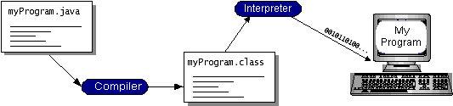

You can think of Java byte codes as the machine code instructions for the Java Virtual Machine (Java VM). Every Java interpreter, whether it’s a development tool or a Web browser that can run applets, is an implementation of the Java VM. Java byte codes help make “write once, run anywhere” possible. You can compile your program into byte codes on any platform that has a Java compiler. The byte codes can then be run on any implementation of the Java VM. That means that as long as a computer has a Java VM, the same program written in the Java programming language can run on Windows 2000, a Solaris workstation, or on an iMac.

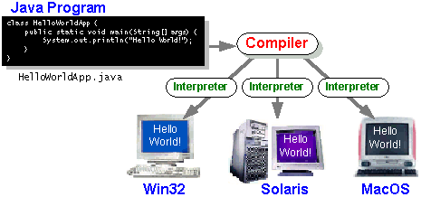

The Java Platform
A platform is the hardware or software environment in which a program runs. We’ve already mentioned some of the most popular platforms like Windows 2000, Linux, Solaris, and MacOS. Most platforms can be described as a combination of the operating system and hardware. The Java platform differs from most other platforms in that it’s a software-only platform that runs on top of other hardware-based platforms.
The Java platform has two components:
- The Java Virtual Machine (Java VM)
- The Java Application Programming Interface (Java API)
You’ve already been introduced to the Java VM. It’s the base for the Java platform and is ported onto various hardware-based platforms.
The Java API is a large collection of ready-made software components that provide many useful capabilities, such as graphical user interface (GUI) widgets. The Java API is grouped into libraries of related classes and interfaces; these libraries are known as packages. The next section, What Can Java Technology Do? Highlights what functionality some of the packages in the Java API provide.
The following figure depicts a program that’s running on the Java platform. As the figure shows, the Java API and the virtual machine insulate the program from the hardware.
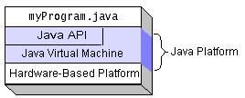
Native code is code that after you compile it, the compiled code runs on a specific hardware platform. As a platform-independent environment, the Java platform can be a bit slower than native code. However, smart compilers, well-tuned interpreters, and just-in-time byte code compilers can bring performance close to that of native code without threatening portability.

What Can Java Technology Do?
The most common types of programs written in the Java programming language are applets and applications. If you’ve surfed the Web, you’re probably already familiar with applets. An applet is a program that adheres to certain conventions that allow it to run within a Java-enabled browser.
However, the Java programming language is not just for writing cute, entertaining applets for the Web. The general-purpose, high-level Java programming language is also a powerful software platform. Using the generous API, you can write many types of programs.
An application is a standalone program that runs directly on the Java platform. A special kind of application known as a server serves and supports clients on a network. Examples of servers are Web servers, proxy servers, mail servers, and print servers. Another specialized program is a servlet. A servlet can almost be thought of as an applet that runs on the server side. Java Servlets are a popular choice for building interactive web applications, replacing the use of CGI scripts. Servlets are similar to applets in that they are runtime extensions of applications. Instead of working in browsers, though, servlets run within Java Web servers, configuring or tailoring the server.
How does the API support all these kinds of programs? It does so with packages of software components that provides a wide range of functionality. Every full implementation of the Java platform gives you the following features:
- The essentials: Objects, strings, threads, numbers, input and output, data structures, system properties, date and time, and so on.
- Applets: The set of conventions used by applets.
- Networking: URLs, TCP (Transmission Control Protocol), UDP (User Data gram Protocol) sockets, and IP (Internet Protocol) addresses.
- Internationalization: Help for writing programs that can be localized for users worldwide. Programs can automatically adapt to specific locales and be displayed in the appropriate language.
- Security: Both low level and high level, including electronic signatures, public and private key management, access control, and certificates.
- Software components: Known as JavaBeansTM, can plug into existing component architectures.
- Object serialization: Allows lightweight persistence and communication via Remote Method Invocation (RMI).
- Java Database Connectivity (JDBCTM): Provides uniform access to a wide range of relational databases.
The Java platform also has APIs for 2D and 3D graphics, accessibility, servers, collaboration, telephony, speech, animation, and more. The following figure depicts what is included in the Java 2 SDK.

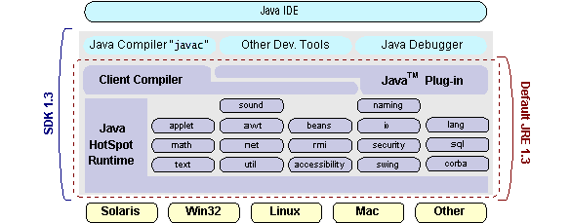

How Will Java Technology Change My Life?
We can’t promise you fame, fortune, or even a job if you learn the Java programming language. Still, it is likely to make your programs better and requires less effort than other languages. We believe that Java technology will help you do the following:
- Get started quickly: Although the Java programming language is a powerful object-oriented language, it’s easy to learn, especially for programmers already familiar with C or C++.
- Write less code: Comparisons of program metrics (class counts, method counts, and so on) suggest that a program written in the Java programming language can be four times smaller than the same program in C++.
- Write better code: The Java programming language encourages good coding practices, and its garbage collection helps you avoid memory leaks. Its object orientation, its JavaBeans component architecture, and its wide-ranging, easily extendible API let you reuse other people’s tested code and introduce fewer bugs.
- Develop programs more quickly: Your development time may be as much as twice as fast versus writing the same program in C++. Why? You write fewer lines of code and it is a simpler programming language than C++.
- Avoid platform dependencies with 100% Pure Java: You can keep your program portable by avoiding the use of libraries written in other languages. The 100% Pure JavaTM Product Certification Program has a repository of historical process manuals, white papers, brochures, and similar materials online.
- Write once, run anywhere: Because 100% Pure Java programs are compiled into machine-independent byte codes, they run consistently on any Java platform.
- Distribute software more easily: You can upgrade applets easily from a central server. Applets take advantage of the feature of allowing new classes to be loaded “on the fly,” without recompiling the entire program.

ODBC
Microsoft Open Database Connectivity (ODBC) is a standard programming interface for application developers and database systems providers. Before ODBC became a de facto standard for Windows programs to interface with database systems, programmers had to use proprietary languages for each database they wanted to connect to. Now, ODBC has made the choice of the database system almost irrelevant from a coding perspective, which is as it should be. Application developers have much more important things to worry about than the syntax that is needed to port their program from one database to another when business needs suddenly change.
Through the ODBC Administrator in Control Panel, you can specify the particular database that is associated with a data source that an ODBC application program is written to use. Think of an ODBC data source as a door with a name on it. Each door will lead you to a particular database. For example, the data source named Sales Figures might be a SQL Server database, whereas the Accounts Payable data source could refer to an Access database. The physical database referred to by a data source can reside anywhere on the LAN.
The ODBC system files are not installed on your system by Windows 95. Rather, they are installed when you setup a separate database application, such as SQL Server Client or Visual Basic 4.0. When the ODBC icon is installed in Control Panel, it uses a file called ODBCINST.DLL. It is also possible to administer your ODBC data sources through a stand-alone program called ODBCADM.EXE. There is a 16-bit and a 32-bit version of this program and each maintains a separate list of ODBC data sources.
From a programming perspective, the beauty of ODBC is that the application can be written to use the same set of function calls to interface with any data source, regardless of the database vendor. The source code of the application doesn’t change whether it talks to Oracle or SQL Server. We only mention these two as an example. There are ODBC drivers available for several dozen popular database systems. Even Excel spreadsheets and plain text files can be turned into data sources. The operating system uses the Registry information written by ODBC Administrator to determine which low-level ODBC drivers are needed to talk to the data source (such as the interface to Oracle or SQL Server). The loading of the ODBC drivers is transparent to the ODBC application program. In a client/server environment, the ODBC API even handles many of the network issues for the application programmer.
The advantages of this scheme are so numerous that you are probably thinking there must be some catch. The only disadvantage of ODBC is that it isn’t as efficient as talking directly to the native database interface. ODBC has had many detractors make the charge that it is too slow. Microsoft has always claimed that the critical factor in performance is the quality of the driver software that is used. In our humble opinion, this is true. The availability of good ODBC drivers has improved a great deal recently. And anyway, the criticism about performance is somewhat analogous to those who said that compilers would never match the speed of pure assembly language. Maybe not, but the compiler (or ODBC) gives you the opportunity to write cleaner programs, which means you finish sooner. Meanwhile, computers get faster every year.

JDBC
In an effort to set an independent database standard API for Java; Sun Microsystems developed Java Database Connectivity, or JDBC. JDBC offers a generic SQL database access mechanism that provides a consistent interface to a variety of RDBMSs. This consistent interface is achieved through the use of “plug-in” database connectivity modules, or drivers. If a database vendor wishes to have JDBC support, he or she must provide the driver for each platform that the database and Java run on.
To gain a wider acceptance of JDBC, Sun based JDBC’s framework on ODBC. As you discovered earlier in this chapter, ODBC has widespread support on a variety of platforms. Basing JDBC on ODBC will allow vendors to bring JDBC drivers to market much faster than developing a completely new connectivity solution.
JDBC was announced in March of 1996. It was released for a 90 day public review that ended June 8, 1996. Because of user input, the final JDBC v1.0 specification was released soon after.
The remainder of this section will cover enough information about JDBC for you to know what it is about and how to use it effectively. This is by no means a complete overview of JDBC. That would fill an entire book.

JDBC Goals
Few software packages are designed without goals in mind. JDBC is one that, because of its many goals, drove the development of the API. These goals, in conjunction with early reviewer feedback, have finalized the JDBC class library into a solid framework for building database applications in Java.
The goals that were set for JDBC are important. They will give you some insight as to why certain classes and functionalities behave the way they do. The eight design goals for JDBC are as follows:

- SQL Level API
The designers felt that their main goal was to define a SQL interface for Java. Although not the lowest database interface level possible, it is at a low enough level for higher-level tools and APIs to be created. Conversely, it is at a high enough level for application programmers to use it confidently. Attaining this goal allows for future tool vendors to “generate” JDBC code and to hide many of JDBC’s complexities from the end user.
- SQL Conformance
SQL syntax varies as you move from database vendor to database vendor. In an effort to support a wide variety of vendors, JDBC will allow any query statement to be passed through it to the underlying database driver. This allows the connectivity module to handle non-standard functionality in a manner that is suitable for its users.
- JDBC must be implemental on top of common database interfaces
The JDBC SQL API must “sit” on top of other common SQL level APIs. This goal allows JDBC to use existing ODBC level drivers by the use of a software interface. This interface would translate JDBC calls to ODBC and vice versa.
- Provide a Java interface that is consistent with the rest of the Java system
Because of Java’s acceptance in the user community thus far, the designers feel that they should not stray from the current design of the core Java system.
- Keep it simple
This goal probably appears in all software design goal listings. JDBC is no exception. Sun felt that the design of JDBC should be very simple, allowing for only one method of completing a task per mechanism. Allowing duplicate functionality only serves to confuse the users of the API.
- Use strong, static typing wherever possible
Strong typing allows for more error checking to be done at compile time; also, less error appear at runtime.
- Keep the common cases simple
Because more often than not, the usual SQL calls used by the programmer are simple SELECT’s, INSERT’s, DELETE’s and UPDATE’s, these queries should be simple to perform with JDBC. However, more complex SQL statements should also be possible.

Finally we decided to proceed the implementation using Java Networking.
And for dynamically updating the cache table we go for MS Access database.
Java ha two things: a programming language and a platform.
Java is a high-level programming language that is all of the following

Simple Architecture-neutral
Object-oriented Portable
Distributed High-performance
Interpreted multithreaded
Robust Dynamic
Secure

Java is also unusual in that each Java program is both compiled and interpreted. With a compile you translate a Java program into an intermediate language called Java byte codes the platform-independent code instruction is passed and run on the computer.

Compilation happens just once; interpretation occurs each time the program is executed. The figure illustrates how this works.

Java Program
Compilers
Interpreter
My Program

You can think of Java byte codes as the machine code instructions for the Java Virtual Machine (Java VM). Every Java interpreter, whether it’s a Java development tool or a Web browser that can run Java applets, is an implementation of the Java VM. The Java VM can also be implemented in hardware.

Java byte codes help make “write once, run anywhere” possible. You can compile your Java program into byte codes on my platform that has a Java compiler. The byte codes can then be run any implementation of the Java VM. For example, the same Java program can run Windows NT, Solaris, and Macintosh.

Networking

TCP/IP stack
The TCP/IP stack is shorter than the OSI one:
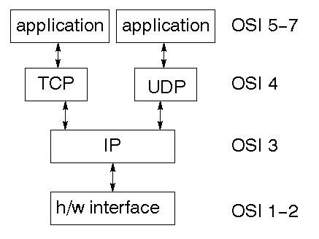
TCP is a connection-oriented protocol; UDP (User Datagram Protocol) is a connectionless protocol.

IP datagram’s
The IP layer provides a connectionless and unreliable delivery system. It considers each datagram independently of the others. Any association between datagram must be supplied by the higher layers. The IP layer supplies a checksum that includes its own header. The header includes the source and destination addresses. The IP layer handles routing through an Internet. It is also responsible for breaking up large datagram into smaller ones for transmission and reassembling them at the other end.

UDP
UDP is also connectionless and unreliable. What it adds to IP is a checksum for the contents of the datagram and port numbers. These are used to give a client/server model - see later.

TCP
TCP supplies logic to give a reliable connection-oriented protocol above IP. It provides a virtual circuit that two processes can use to communicate.

Internet addresses
In order to use a service, you must be able to find it. The Internet uses an address scheme for machines so that they can be located. The address is a 32 bit integer which gives the IP address. This encodes a network ID and more addressing. The network ID falls into various classes according to the size of the network address.

Network address
Class A uses 8 bits for the network address with 24 bits left over for other addressing. Class B uses 16 bit network addressing. Class C uses 24 bit network addressing and class D uses all 32.

Subnet address
Internally, the UNIX network is divided into sub networks. Building 11 is currently on one sub network and uses 10-bit addressing, allowing 1024 different hosts.

Host address
8 bits are finally used for host addresses within our subnet. This places a limit of 256 machines that can be on the subnet.

Total address

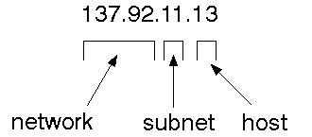
The 32 bit address is usually written as 4 integers separated by dots.

Port addresses
A service exists on a host, and is identified by its port. This is a 16 bit number. To send a message to a server, you send it to the port for that service of the host that it is running on. This is not location transparency! Certain of these ports are "well known".

Sockets
A socket is a data structure maintained by the system to handle network connections. A socket is created using the call socket. It returns an integer that is like a file descriptor. In fact, under Windows, this handle can be used with Read File and Write File functions.
#include <sys/types.h>
#include <sys/socket.h>
int socket(int family, int type, int protocol);
Here "family" will be AF_INET for IP communications, protocol will be zero, and type will depend on whether TCP or UDP is used. Two processes wishing to communicate over a network create a socket each. These are similar to two ends of a pipe - but the actual pipe does not yet exist.
JFree Chart
JFreeChart is a free 100% Java chart library that makes it easy for developers to display professional quality charts in their applications. JFreeChart's extensive feature set includes:
A consistent and well-documented API, supporting a wide range of chart types;
A flexible design that is easy to extend, and targets both server-side and client-side applications;
Support for many output types, including Swing components, image files (including PNG and JPEG), and vector graphics file formats (including PDF, EPS and SVG);
JFreeChart is "open source" or, more specifically, free software. It is distributed under the terms of the GNU Lesser General Public Licence (LGPL), which permits use in proprietary applications.

1. Map Visualizations
Charts showing values that relate to geographical areas. Some examples include: (a) population density in each state of the United States, (b) income per capita for each country in Europe, (c) life expectancy in each country of the world. The tasks in this project include:
Sourcing freely redistributable vector outlines for the countries of the world, states/provinces in particular countries (USA in particular, but also other areas);
Creating an appropriate dataset interface (plus default implementation), a rendered, and integrating this with the existing XYPlot class in JFreeChart;
Testing, documenting, testing some more, documenting some more.

2. Time Series Chart Interactivity

Implement a new (to JFreeChart) feature for interactive time series charts --- to display a separate control that shows a small version of ALL the time series data, with a sliding "view" rectangle that allows you to select the subset of the time series data to display in the main chart.

3. Dashboards

There is currently a lot of interest in dashboard displays. Create a flexible dashboard mechanism that supports a subset of JFreeChart chart types (dials, pies, thermometers, bars, and lines/time series) that can be delivered easily via both Java Web Start and an applet.

4. Property Editors

The property editor mechanism in JFreeChart only handles a small subset of the properties that can be set for charts. Extend (or reimplement) this mechanism to provide greater end-user control over the appearance of the charts.

J2ME (Java 2 Micro edition):-

Sun Microsystems defines J2ME as "a highly optimized Java run-time environment targeting a wide range of consumer products, including pagers, cellular phones, screen-phones, digital set-top boxes and car navigation systems." Announced in June 1999 at the JavaOne Developer Conference, J2ME brings the cross-platform functionality of the Java language to smaller devices, allowing mobile wireless devices to share applications. With J2ME, Sun has adapted the Java platform for consumer products that incorporate or are based on small computing devices.

1. General J2ME architecture

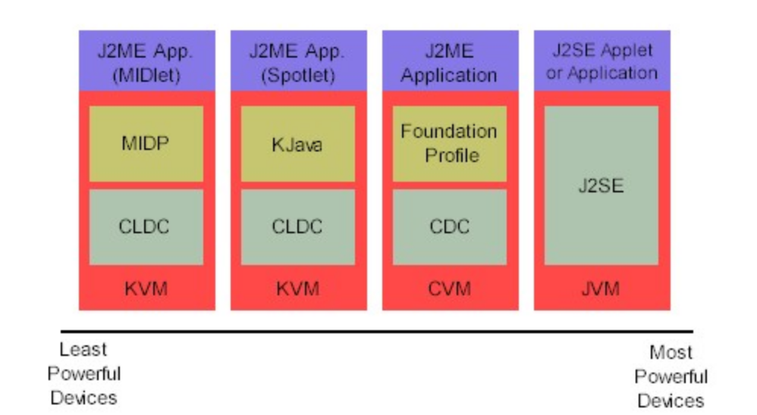

J2ME uses configurations and profiles to customize the Java Runtime Environment (JRE). As a complete JRE, J2ME is comprised of a configuration, which determines the JVM used, and a profile, which defines the application by adding domain-specific classes. The configuration defines the basic run-time environment as a set of core classes and a specific JVM that run on specific types of devices. We'll discuss configurations in detail in the The profile defines the application; specifically, it adds domain-specific classes to the J2ME configuration to define certain uses for devices. We'll cover profiles in depth in the The following graphic depicts the relationship between the different virtual machines, configurations, and profiles. It also draws a parallel with the J2SE API and its Java virtual machine. While the J2SE virtual machine is generally referred to as a JVM, the J2ME virtual machines, KVM and CVM, are subsets of JVM. Both KVM and CVM can be thought of as a kind of Java virtual machine -- it's just that they are shrunken versions of the J2SE JVM and are specific to J2ME.

2.Developing J2ME applications

Introduction In this section, we will go over some considerations you need to keep in mind when developing applications for smaller devices. We'll take a look at the way the compiler is invoked when using J2SE to compile J2ME applications. Finally, we'll explore packaging and deployment and the role preverification plays in this process.

3.Design considerations for small devices

Developing applications for small devices requires you to keep certain strategies in mind during the design phase. It is best to strategically design an application for a small device before you begin coding. Correcting the code because you failed to consider all of the "gotchas" before developing the application can be a painful process. Here are some design strategies to consider:
* Keep it simple. Remove unnecessary features, possibly making those features a separate, secondary application.
* Smaller is better. This consideration should be a "no brainer" for all developers. Smaller applications use less memory on the device and require shorter installation times. Consider packaging your Java applications as compressed Java Archive (jar) files.
* Minimize run-time memory use. To minimize the amount of memory used at run time, use scalar types in place of object types. Also, do not depend on the garbage collector. You should manage the memory efficiently yourself by setting object references to null when you are finished with them. Another way to reduce run-time memory is to use lazy instantiation, only allocating objects on an as-needed basis. Other ways of reducing overall and peak memory use on small devices are to release resources quickly, reuse objects, and avoid exceptions.

4.Configurations overview
The configuration defines the basic run-time environment as a set of core classes and a specific JVM that run on specific types of devices. Currently, two configurations exist for J2ME, though others may be defined in the future:
* Connected Limited Device Configuration (CLDC) is used specifically with the KVM for 16-bit or 32-bit devices with limited amounts of memory. This is the configuration (and the virtual machine) used for developing small J2ME applications. Its size limitations make CLDC more interesting and challenging (from a development point of view) than CDC. CLDC is also the configuration that we will use for developing our drawing tool application. An example of a small wireless device running small applications is a Palm hand-held computer.

* Connected Device Configuration (CDC) is used with the C virtual machine (CVM) and is used for 32-bit architectures requiring more than 2 MB of memory. An example of such a device is a Net TV box.

5.J2ME profiles

What is a J2ME profile?
As we mentioned earlier in this tutorial, a profile defines the type of device supported. The Mobile Information Device Profile (MIDP), for example, defines classes for cellular phones. It adds domain-specific classes to the J2ME configuration to define uses for similar devices. Two profiles have been defined for J2ME and are built upon CLDC: KJava and MIDP. Both KJava and MIDP are associated with CLDC and smaller devices. Profiles are built on top of configurations. Because profiles are specific to the size of the device (amount of memory) on which an application runs, certain profiles are associated with certain configurations.
A skeleton profile upon which you can create your own profile, the Foundation Profile, is available for CDC.
Profile 1: KJava
KJava is Sun's proprietary profile and contains the KJava API. The KJava profile is built on top of the CLDC configuration. The KJava virtual machine, KVM, accepts the same byte codes and class file format as the classic J2SE virtual machine. KJava contains a Sun-specific API that runs on the Palm OS. The KJava API has a great deal in common with the J2SE Abstract Windowing Toolkit (AWT). However, because it is not a standard J2ME package, its main package is com.sun.kjava. We'll learn more about the KJava API later in this tutorial when we develop some sample applications.
Profile 2: MIDP
MIDP is geared toward mobile devices such as cellular phones and pagers. The MIDP, like KJava, is built upon CLDC and provides a standard run-time environment that allows new applications and services to be deployed dynamically on end user devices. MIDP is a common, industry-standard profile for mobile devices that is not dependent on a specific vendor. It is a complete and supported foundation for mobile application
development. MIDP contains the following packages, the first three of which are core CLDC packages, plus three MIDP-specific packages.
* java.lang
* java.io
* java.util
* javax.microedition.io
* javax.microedition.lcdui
* javax.microedition.midlet
* javax.microedition.rms

Netbeans IDE(Work bench):

An Introduction to Java Development with NetBeans IDE

In a nutshell, what is the NetBeans IDE?

NetBeans IDE is a free, open source, popular (with approximately 1 million downloads), integrated development environment used by many developers. Out of the box, it provides built-in support for developing in Java, C, C++, XML, and HTML. And this author especially likes the support for editing JSPs, including syntax highlighting, HTML tag completion, JSP tag completion, and Java code completion.

NetBeans IDE is available for free downloaded at http://www.netbeans.org

Following are step-by-step instructions to help NetBeans IDE greenhorns to get started developing Java
applications with NetBeans IDE. The basic steps described are as follows.

1. Create a new project
2. Mount a directory - specify a location to save project files
3. Add a new class to the project
4. Compile and run a Java program
1. Create a New Project

Start NetBeans:

1. Start a new project: Main Menu -> Project -> Project Manager -> New Project

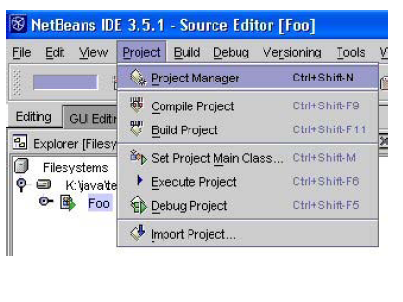

Click New.
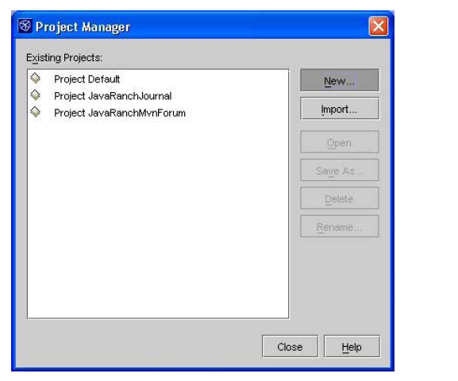

Give the project a name. Click OK.

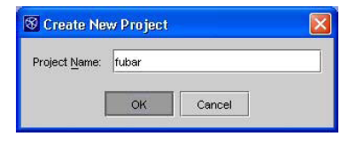
2. Mount a directory - specify a location to save project files
To specify a location on a disk drive where project files will be stored, mount a directory as part of the
project.

To the project, add a directory to hold project files: Main Menu -> File -> Mount Filesystem...

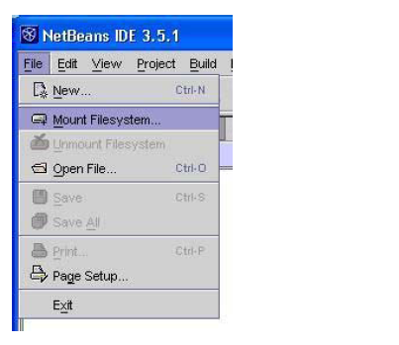
Under Filesystems, Select Local Directory. Click Next.

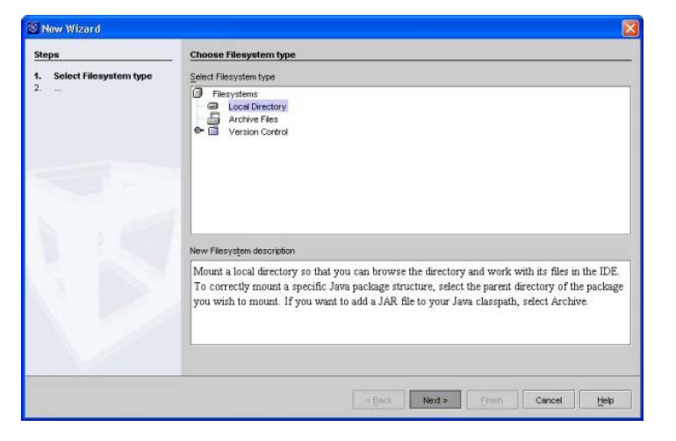

Select a directory to hold the project. (Note: Don't open the desired directory, just select it. If you accidentally open the desired directory, just click the up directory arrow next to the "Look in" drop down list, and then select the desired project directory with a single click.) Click Finish.
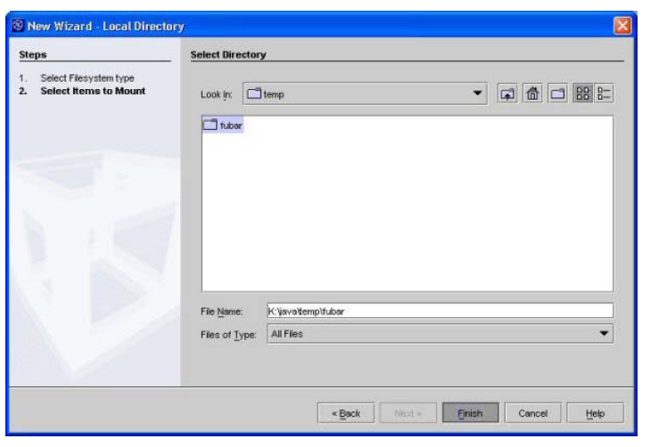

3. Add a new class to the project

Right mouse click on a mounted project directory. Select New -> Java Class

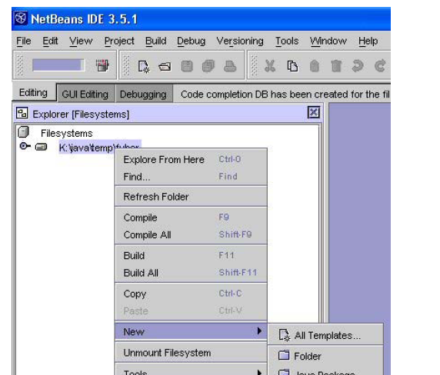

Name the class and click Finish.

Edit the Java class as desired. Following is the code used in this tutorial.

public class Foo{
public static void main(String[] args)
{
System.out.println("Hello World!");
}
}
4. Compile and run a Java program
In the Filesystems Explorer, assure that the main Java class is selected.
Go to Main Menu -> Build -> Execute to compile and run the main Java class in one step.

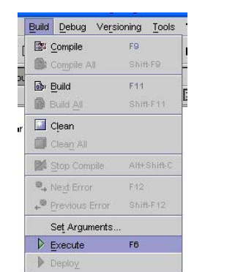

Note: To just compile a class, go to Main Menu -> Build -> Compile.

After executing, you should see results similar to the following. (Note that the NetBeans IDE captures console output, not unlike JBuilder. So, the output of this program appears in the lower IDE panel.)
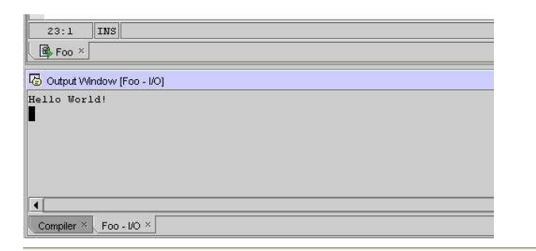

A Swing Architecture Overview
The Inside Story on JFC Component Design


Most Swing developers know by now that Swing components have a separable model-and-view design. And many Swing users have run across articles saying that Swing is based on something called a "modified MVC (model-view-controller) architecture."
But accurate explanations of how Swing components are designed, and how their parts all fit together, have been hard to come by -- until now.
The silence ends with the publication of this article, a major white paper on Swing component design. It provides a comprehensive technical overview of Swing's modified MVC structure and demystifies many other facets of Swing component architecture as well.
This document presents a technical overview of the Swing component architecture. In particular, it covers the following areas in detail:
- Design goals
- Roots in MVC
- Separable model architecture
- Pluggable look-and-feel architecture

Design Goals
The overall goal for the Swing project was:
To build a set of extensible GUI components to enable developers to more rapidly develop powerful Java front ends for commercial applications.
To this end, the Swing team established a set of design goals early in the project that drove the resulting architecture. These guidelines mandated that Swing would:
- Be implemented entirely in Java to promote cross-platform consistency and easier maintenance.
- Provide a single API capable of supporting multiple look-and-feels so that developers and end-users would not be locked into a single look-and-feel.
- Enable the power of model-driven programming without requiring it in the highest-level API.
- Adhere to JavaBeans design principles to ensure that components behave well in IDEs and builder tools.
- Provide compatibility with AWT APIs where there is overlapping, to leverage the AWT knowledge base and ease porting.

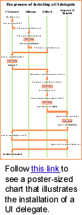

Roots in MVC
Swing architecture is rooted in the model-view-controller (MVC) design that dates back to SmallTalk. MVC architecture calls for a visual application to be broken up into three separate parts:
- A model that represents the data for the application.
- The view that is the visual representation of that data.
- A controller that takes user input on the view and translates that to changes in the model.
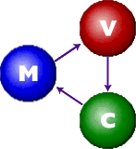
Early on, MVC was a logical choice for Swing because it provided a basis for meeting the first three of our design goals within the bounds of the latter two.
The first Swing prototype followed a traditional MVC separation in which each component had a separate model object and delegated its look-and-feel implementation to separate view and controller objects.

The delegate
We quickly discovered that this split didn't work well in practical terms because the view and controller parts of a component required a tight coupling (for example, it was very difficult to write a generic controller that didn't know specifics about the view). So we collapsed these two entities into a single UI (user-interface) object, as shown in this diagram:
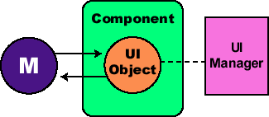
(The UI delegate object shown in this picture is sometimes called a delegate object, or UI delegate. The UI delegate used in Swing is described in more detail in the Pluggable look-and-feel section of this article, under the subheading "The UI delegate".)
As the diagram illustrates, Swing architecture is loosely based -- but not strictly based -- on the traditional MVC design. In the world of Swing, this new quasi-MVC design is sometimes referred to a separable model architecture.
Swing's separable model design treats the model part of a component as a separate element, just as the MVC design does. But Swing collapses the view and controller parts of each component into a single UI (user-interface) object.

To MVC or not to MVC?
One noteworthy point is that as an application developer, you should think of a component's view/controller responsibilities as being handled by the generic component class (such as. JButton, JTree, and so on). The component class then delegates the look-and-feel-specific aspects of those responsibilities to the UI object that is provided by the currently installed look-and-feel.
For example, the code that implements double-buffered painting is in Swing's JComponent class (the "mother" of most Swing component classes), while the code that renders a JButton's label is in the button's UI delegate class. The preceding diagram illustrates this subtle (and often confusing) point:

So Swing does have a strong MVC lineage. But it's also important to reiterate that our MVC architecture serves two distinct purposes:
- First, separating the model definition from a component facilitates model-driven programming in Swing.
- Second, the ability to delegate some of a component's view/controller responsibilities to separate look-and-feel objects provides the basis for Swing's pluggable look-and-feel architecture.
Although these two concepts are linked by the MVC design, they may be treated somewhat orthogonally from the developer's perspective. The remainder of this document will cover each of these mechanisms in greater detail.

Separable model architecture
It is generally considered good practice to center the architecture of an application around its data rather than around its user interface. To support this paradigm, Swing defines a separate model interface for each component that has a logical data or value abstraction. This separation provides programs with the option of plugging in their own model implementations for Swing components.
The following table shows the component-to-model mapping for Swing.
Component | Model Interface | Model Type
JButton | ButtonModel | GUI
JToggleButton | ButtonModel | GUI/data
JCheckBox | ButtonModel | GUI/data
JRadioButton | ButtonModel | GUI/data
JMenu | ButtonModel | GUI
JMenuItem | ButtonModel | GUI
JCheckBoxMenuItem | ButtonModel | GUI/data
JRadioButtonMenuItem | ButtonModel | GUI/data
JComboBox | ComboBoxModel | data
JProgressBar | BoundedRangeModel | GUI/data
JScrollBar | BoundedRangeModel | GUI/data
JSlider | BoundedRangeModel | GUI/data
JTabbedPane | SingleSelectionModel | GUI
JList | ListModel | data
JList | ListSelectionModel | GUI
JTable | TableModel | data
JTable | TableColumnModel | GUI
JTree | TreeModel | data
JTree | TreeSelectionModel | GUI
JEditorPane | Document | data
JTextPane | Document | data
JTextArea | Document | data
JTextField | Document | data
JPasswordField | Document | data

GUI-state vs. application-data models
The models provided by Swing fall into two general categories: GUI-state models and application-data models.

GUI-state models
GUI state models are interfaces that define the visual status of a GUI control, such as whether a button is pressed or armed, or which items are selected in a list. GUI-state models typically are relevant only in the context of a graphical user interface (GUI). While it is often useful to develop programs using GUI-state model separation -- particularly if multiple GUI controls are linked to a common state (such as in a shared whiteboard program), or if manipulating one control automatically changes the value of another -- the use of GUI-state models is not required by Swing. It is possible to manipulate the state of a GUI control through top-level methods on the component, without any direct interaction with the model at all. In the preceding table, GUI-state models in Swing are highlighted in blue.

Application-data models
An application-data model is an interface that represents some quantifiable data that has meaning primarily in the context of the application, such as the value of a cell in a table or the items displayed in a list. These data models provide a very powerful programming paradigm for Swing programs that need a clean separation between their application data/logic and their GUI. For truly data-centric Swing components, such as JTree and JTable, interaction with the data model is strongly recommended. Application-data models are highlighted in red in the table presented at the beginning of this section.
Of course with some components, the model categorization falls somewhere in between GUI state models and application-data models, depending on the context in which the model is used. This is the case with the BoundedRangeModel on JSlider or JProgressBar. These models are highlighted in purple in the preceding table.
Swing's separable model API makes no specific distinctions between GUI state models and application-data models; however, we have clarified this difference here to give developers a better understanding of when and why they might wish to program with the separable models.

Shared model definitions
Referring again to the table at the beginning of this section, notice that model definitions are shared across components in cases where the data abstraction for each component is similar enough to support a single interface without over-genericizing that interface. Common models enable automatic connectability between component types. For example, because both JSlider and JScrollbar use the BoundedRangeModel interface, a single BoundedRangeModel instance could be plugged into both a JScrollbar and a JSlider and their visual state would always remain in sync.
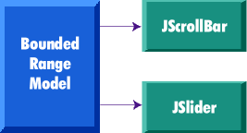

The separable-model API
Swing components that define models support a JavaBeans bound property for the model. For example, JSlider uses the BoundedRangeModel interface for its model definition. Consequently, it includes the following methods:
public BoundedRangeModel getModel()
public void setModel(BoundedRangeModel model)
All Swing components have one thing in common: If you don't set your own model, a default is created and installed internally in the component. The naming convention for these default model classes is to prepend the interface name with "Default." For JSlider, a DefaultBoundedRangeModel object is instantiated in its constructor:
public JSlider(int orientation, int min,
int max, int value)
{
checkOrientation(orientation);
this.orientation = orientation;
this.model =
new DefaultBoundedRangeModel(value, 0, min, max);
this.model.addChangeListener(changeListener);
updateUI();
}

If a program subsequently calls setModel(), this default model is replaced, as in the following example:
JSlider slider = new JSlider();
BoundedRangeModel myModel =
new DefaultBoundedRangeModel() {
public void setValue(int n) {
System.out.println("SetValue: "+ n);
super.setValue(n);
}
});
slider.setModel(myModel);

For more complex models (such as those for JTable and JList), an abstract model implementation is also provided to enable developers to create their own models without starting from scratch. These classes are prepended with "Abstract".
For example, JList's model interface is ListModel, which provides both DefaultListModel and AbstractListModel classes to help the developer in building a list model.

Model change notification
Models must be able to notify any interested parties (such as views) when their data or value changes. Swing models use the JavaBeans Event model for the implementation of this notification. There are two approaches for this notification used in Swing:
- Send a lightweight notification that the state has "changed" and require the listener to respond by sending a query back to the model to find out what has changed. The advantage of this approach is that a single event instance can be used for all notifications from a particular model -- which is highly desirable when the notifications tend to be high in frequency (such as when a JScrollBar is dragged).
- Send a stateful notification that describes more precisely how the model has changed. This alternative requires a new event instance for each notification. It is desirable when a generic notification doesn't provide the listener with enough information to determine efficiently what has changed by querying the model (such as when a column of cells change value in a JTable).

Lightweight notification
The following models in Swing use the lightweight notification, which is based on the ChangeListener/ChangeEvent API:
Model | Listener | Event
BoundedRangeModel | ChangeListener | ChangeEvent
ButtonModel | ChangeListener | ChangeEvent
SingleSelectionModel | ChangeListener | ChangeEvent
The ChangeListener interface has a single generic method:
public void stateChanged(ChangeEvent e)
The only state in a ChangeEvent is the event "source." Because the source is always the same across notifications, a single instance can be used for all notifications from a particular model. Models that use this mechanism support the following methods to add and remove ChangeListeners:
public void addChangeListener(ChangeListener l)
public void removeChangeListener(ChangeListener l)
Therefore, to be notified when the value of a JSlider has changed, the code might look like this:
JSlider slider = new JSlider();
BoundedRangeModel model = slider.getModel();
model.addChangeListener(new ChangeListener() {
public void stateChanged(ChangeEvent e) {
// need to query the model
// to get updated value...
BoundedRangeModel m =
(BoundedRangeModel)e.getSource();
System.out.println("model changed: " +
m.getValue());
}
});

To provide convenience for programs that don't wish to deal with separate model objects, some Swing component classes also provide the ability to register ChangeListeners directly on the component (so the component can listen for changes on the model internally and then propagates those events to any listeners registered directly on the component). The only difference between these notifications is that for the model case, the event source is the model instance, while for the component case, the source is the component.
So we could simplify the preceding example to:
JSlider slider = new JSlider();
slider.addChangeListener(new ChangeListener() {
public void stateChanged(ChangeEvent e) {
// the source will be
// the slider this time..
JSlider s = (JSlider)e.getSource();
System.out.println("value changed: " +
s.getValue());
}
});

Working with Swing Application in Net Beans:

The NetBeans IDE is a free, open-source Integrated Development Environment for software developers. We will get all the tools we need to create professional desktop, enterprise, web and mobile applications, in Java, C/C++ and even Ruby. The IDE runs on many platforms including Windows, Linux, Mac OS X and Solaris; it is easy to install and use straight out of the box.
The 6.0 release includes significant enhancements and new features, including a completely rewritten editor infrastructure, support for additional languages, new productivity features, and a simplified installation process that allows you to easily install and configure the IDE to meet our exact needs.

The IDE's GUI Builder makes it possible to build professional-looking GUIs without an intimate understanding of layout Accelerators. You can lay out your forms by simply placing components where you want them.

Creating a Project:
Because all Java development in the IDE takes place within projects, we first need to create a new Contact Editor project within which to store sources and other project files. An IDE project is a group of Java source files plus its associated meta data, including project-specific properties files, an Ant build script that controls the build and run settings, and a project.xml file that maps Ant targets to IDE commands. While Java applications often consist of several IDE projects, for the purposes of this tutorial, we will build a simple application which is stored entirely in a single project.

Steps to create a GUI application:
1.Use the GUI Builder Interface
2.Create a GUI Container
3.Add Components
4.Resize Components
5.Align Components
6.Adjust Component Anchoring
7.Set Component Auto-Resizing Behavior
8.Edit Component Properties

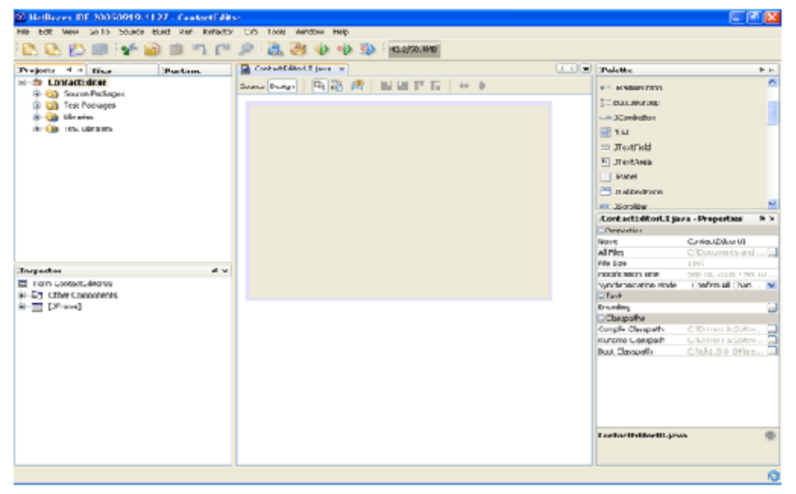
screen-shot shows the netbeans IDE view.
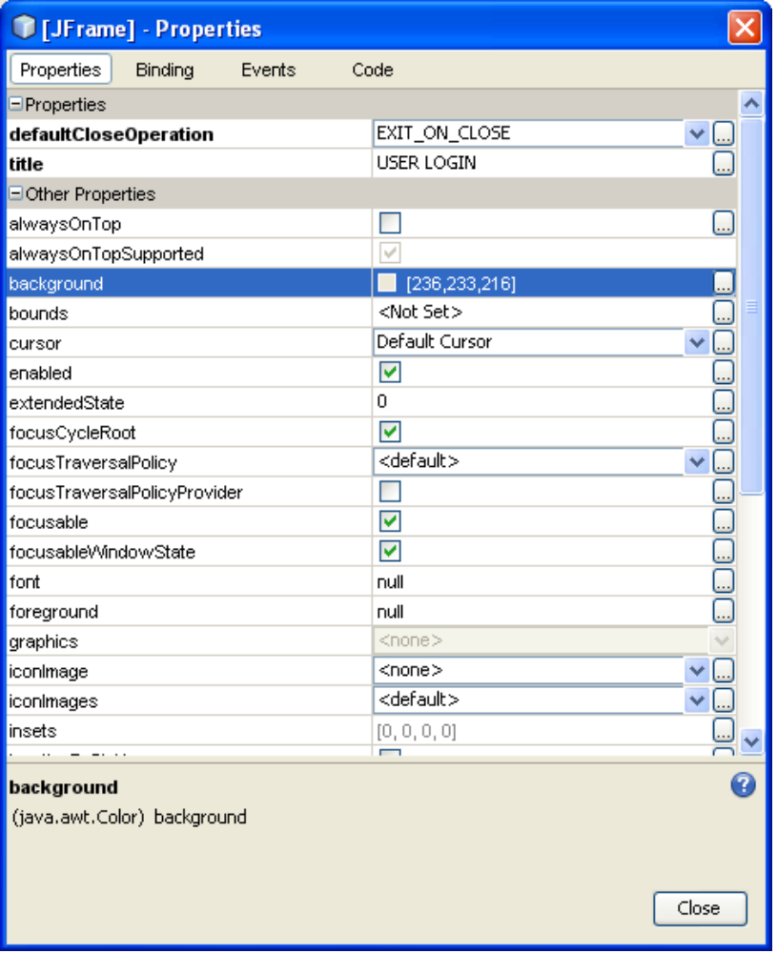

Screent shot shows the properties dialog for JFrame window.

To create a new ContactEditor application project:
- Choose File > New Project. Alternately, you can click the New Project icon in the IDE toolbar.
- In the Categories pane, select the Java node and in the Projects pane, choose Java Application. Click Next.
- Enter ContactEditor in the Project Name field and specify the project location.
- Ensure that the Set as Main Project checkbox is selected and clear the Create Main Class field.
- Click Finish.

Creating a GUI container:
After creating the new application, you may have noticed that the Source Packages folder in the Projects window contains an empty <default package> node. To proceed with building our interface, we need to create a Java container within which we will place the other required GUI components. In this step we'll create a container using the JFrame component and place the container in a new package.
We can use the GUI builder to prototype GUIs applications. Designing of Swing GUIs by dragging and positioning GUI components from a palette onto a canvas. The GUI builder automatically takes care of the correct spacing and alignment. Click into JLabels, JButtons, JTextFields and edit their properties directly in place.

The new help bar displays context-sensitive hints about what can be done with the selected component and which shortcuts can speed up the work . The NetBeans IDE comes with built-in support for GUI localization and accessibility.
Standard and Custom GUI Components:
The extensible Component Palette comes with pre-installed Swing and AWT components and includes a visual menu designer. Use the Component Inspector to view a component's tree and properties

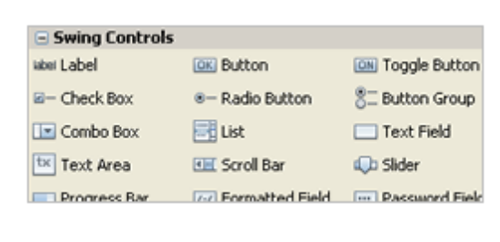
Swing Application FrameWork:
The Swing Application Framework simplifies the handling of the application life cycle, actions and resources. Take advantage of the provided code-generation tools and building blocks, and develop small to medium-sized desktop applications faster than ever. Create menus fast and intuitively by dragging and dropping menu items onto the canvas; you can add mnemonics and rename menu items inline by clicking and typing in the Design view.
Introduction to Applets:
In this Section you will learn about the lifecycle of an applet and different methods of an applet. Applet runs in the browser and its lifecycle method are called by JVM when it is loaded and destroyed. Here are the lifecycle methods of an Applet:
init(): This method is called to initialized an applet
start(): This method is called after the initialization of the applet.
stop(): This method can be called multiple times in the life cycle of an Applet.
destroy(): This method is called only once in the life cycle of the applet when applet is destroyed.
init () method: The life cycle of an applet is begin on that time when the applet is first loaded into the browser and called the init() method. The init() method is called only one time in the life cycle on an applet. The init() method is basically called to read the PARAM tag in the html file. The init () method retrieve the passed parameter through the PARAM tag of html file using get Parameter() method All the initialization such as initialization of variables and the objects like image, sound file are loaded in the init () method .After the initialization of the init() method user can interact with the Applet and mostly applet contains the init() method.
Start () method: The start method of an applet is called after the initialization method init(). This method may be called multiples time when the Applet needs to be started or restarted. For Example if the user wants to return to the Applet, in this situation the start Method() of an Applet will be called by the web browser and the user will be back on the applet. In the start method user can interact within the applet.
Stop () method: The stop() method can be called multiple times in the life cycle of applet like the start () method. Or should be called at least one time. There is only miner difference between the start() method and stop () method. For example the stop() method is called by the web browser on that time When the user leaves one applet to go another applet and the start() method is called on that time when the user wants to go back into the first program or Applet.
destroy() method: The destroy() method is called only one time in the life cycle of Applet like init() method. This method is called only on that time when the browser needs to Shut down.

